**Roll No:63**

**Student Name:Rutuja Ashok Sathe**

**Assignment No: 2-A**

Design and Develop SQL DDL statements which demonstrate the use of SQL objects such as

Table, View, Index, Sequence, Synonym

Use database sathe

create table Department(dept_no int,dept_name varchar(15),bldg_name varchar(15),unique(dept_name));

mysql> use sathe

Database changed

mysql> create table Department(dept_no int,dept_name varchar(15),bldg_name

-> varchar(15),unique(dept_name));

ERROR 1050 (42S01): Table 'department' already exists

mysql> desc Department;

+-----------+-------------+------+-----+---------+-------+

| Field | Type | Null | Key | Default | Extra |

+-----------+-------------+------+-----+---------+-------+

| dept_no | int | YES | | NULL | |

| dept_name | varchar(15) | YES | UNI | NULL | |

| bldg_name | varchar(15) | YES | | NULL | |

+-----------+-------------+------+-----+---------+-------+

3 rows in set (0.03 sec)

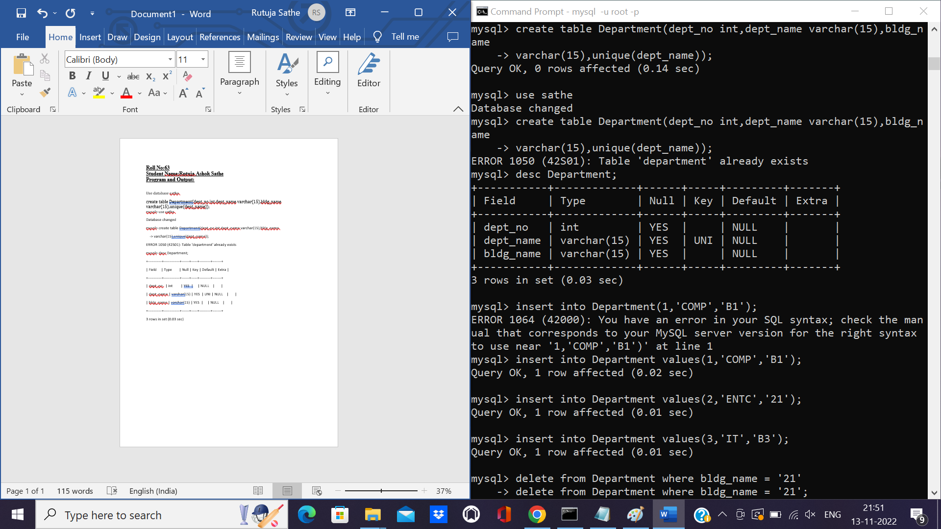

Insert into Department (dept_no,dept_name,bldg_name) values (1,’COMP’,’B1’);

Insert into Department (dept_no,dept_name,bldg_name) values (2,’ENTC’,’B2’);

Insert into Department (dept_no,dept_name,bldg_name) values (3,’IT’,’B3’);

mysql> insert into Department values(1,'COMP','B1');

Query OK, 1 row affected (0.02 sec)

mysql> insert into Department values(2,'ENTC','21');

Query OK, 1 row affected (0.01 sec)

mysql> insert into Department values(3,'IT','B3');

Query OK, 1 row affected (0.01 sec)

mysql> delete from Department where dept_name = 'ENTC';

Query OK, 1 row affected (0.01 sec)

mysql> insert into Department values(2,'ENTC','B2');

Query OK, 1 row affected (0.01 sec)

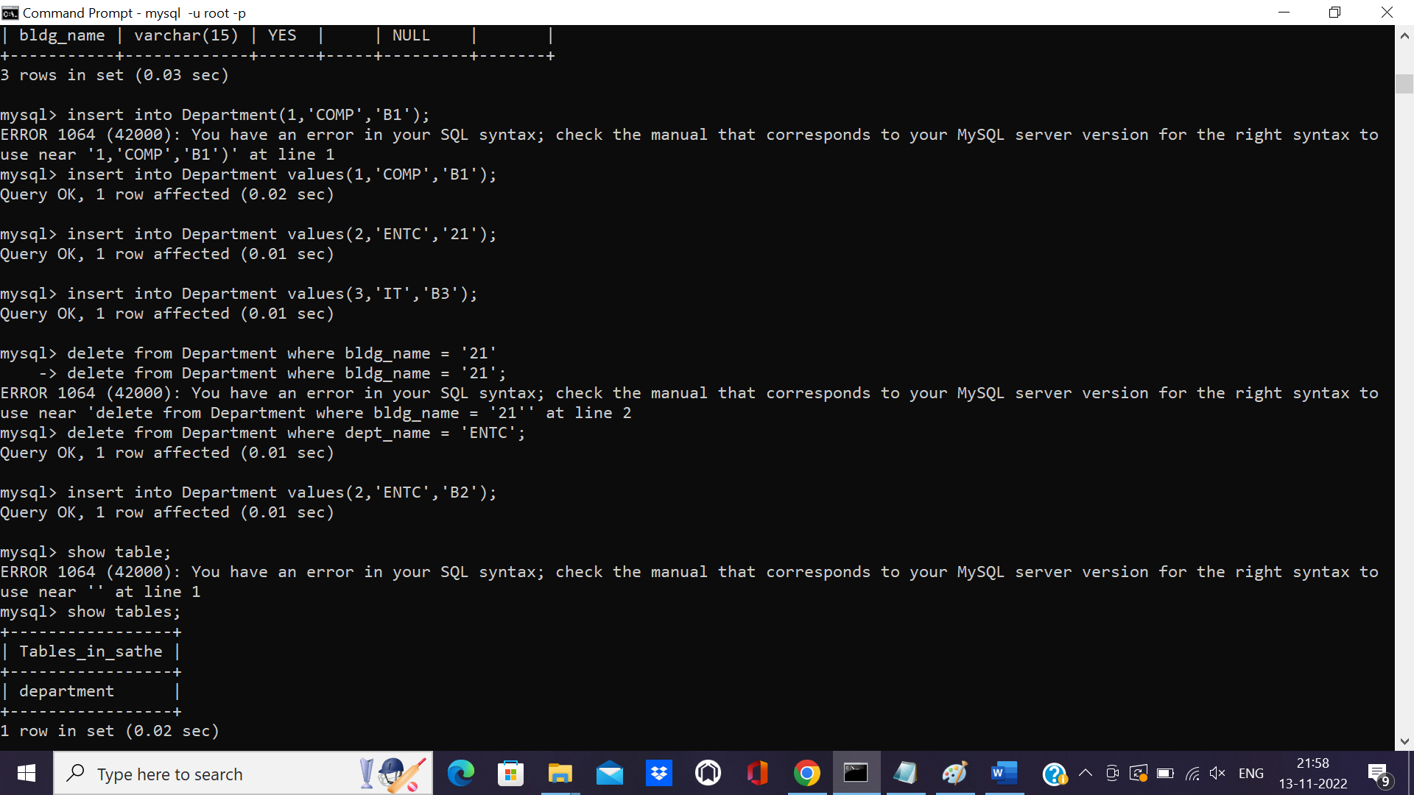

mysql> create table instructor(ins_id int,ins_name varchar(15) not null,dept_no int,salary

-> int,mob_no int,primary key(ins_id));

Query OK, 0 rows affected (0.03 sec)

mysql> desc instructor;

+----------+-------------+------+-----+---------+-------+

| Field | Type | Null | Key | Default | Extra |

+----------+-------------+------+-----+---------+-------+

| ins_id | int | NO | PRI | NULL | |

| ins_name | varchar(15) | NO | | NULL | |

| dept_no | int | YES | | NULL | |

| salary | int | YES | | NULL | |

| mob_no | int | YES | | NULL | |

+----------+-------------+------+-----+---------+-------+

5 rows in set (0.00 sec)

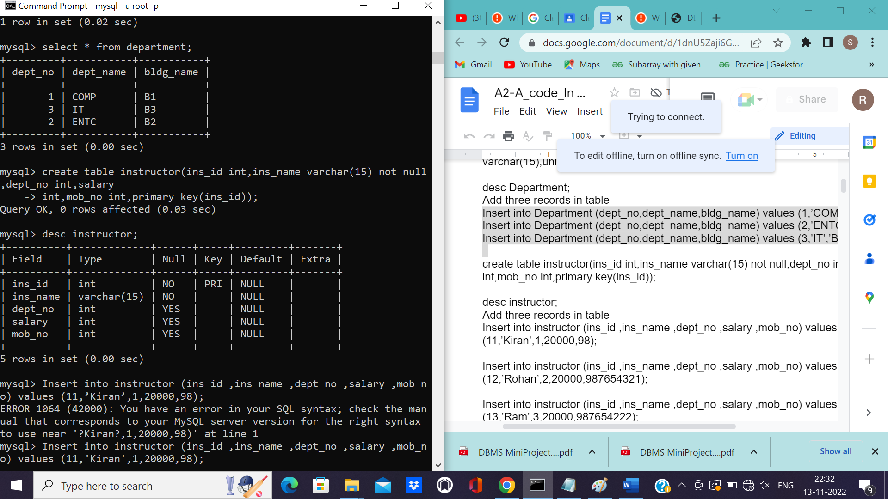

mysql> Insert into instructor (ins_id ,ins_name ,dept_no ,salary ,mob_no) values (11,’Kiran’,1,20000,98);

mysql> Insert into instructor (ins_id ,ins_name ,dept_no ,salary ,mob_no) values (11,'Kiran',1,20000,98);

Query OK, 1 row affected (0.01 sec)

mysql> Insert into instructor (ins_id ,ins_name ,dept_no ,salary ,mob_no) values (12,'Rohan',2,20000,987654321);

Query OK, 1 row affected (0.01 sec)

mysql> Insert into instructor (ins_id ,ins_name ,dept_no ,salary ,mob_no) values (13,'Hrituja',3,20000,987654222);

Query OK, 1 row affected (0.01 sec)

mysql> create table course(course_id int,title varchar(15),dept_no int,credits int,primary

-> key(course_id));

Query OK, 0 rows affected (0.03 sec)

mysql> select * from instructor;

+--------+----------+---------+--------+-----------+

| ins_id | ins_name | dept_no | salary | mob_no |

+--------+----------+---------+--------+-----------+

| 11 | Kiran | 1 | 20000 | 98 |

| 12 | Rohan | 2 | 20000 | 987654321 |

| 13 | Hrituja | 3 | 20000 | 987654222 |

+--------+----------+---------+--------+-----------+

3 rows in set (0.00 sec)

mysql> Insert into course (course_id ,title,dept_no ,credits ) values (111,'COMP',1,10);

Query OK, 1 row affected (0.01 sec)

mysql> Insert into course (course_id ,title,dept_no ,credits ) values (222,'ENTC',2,10);

Query OK, 1 row affected (0.01 sec)

mysql> Insert into course (course_id ,title,dept_no ,credits ) values (333,'IT',3,10);

Query OK, 1 row affected (0.01 sec)

mysql> select * from course;

+-----------+-------+---------+---------+

| course_id | title | dept_no | credits |

+-----------+-------+---------+---------+

| 111 | COMP | 1 | 10 |

| 222 | ENTC | 2 | 10 |

| 333 | IT | 3 | 10 |

+-----------+-------+---------+---------+

3 rows in set (0.00 sec)

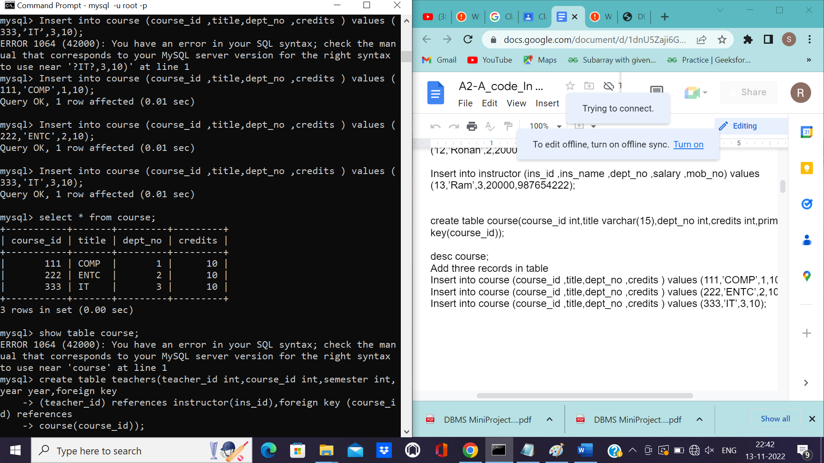

mysql> create table teachers(teacher_id int,course_id int,semester int,year year,foreign key

-> (teacher_id) references instructor(ins_id),foreign key (course_id) references

-> course(course_id));

Query OK, 0 rows affected (0.05 sec)

mysql> desc teachers;

+------------+------+------+-----+---------+-------+

| Field | Type | Null | Key | Default | Extra |

+------------+------+------+-----+---------+-------+

| teacher_id | int | YES | MUL | NULL | |

| course_id | int | YES | MUL | NULL | |

| semester | int | YES | | NULL | |

| year | year | YES | | NULL | |

+------------+------+------+-----+---------+-------+

4 rows in set (0.00 sec)

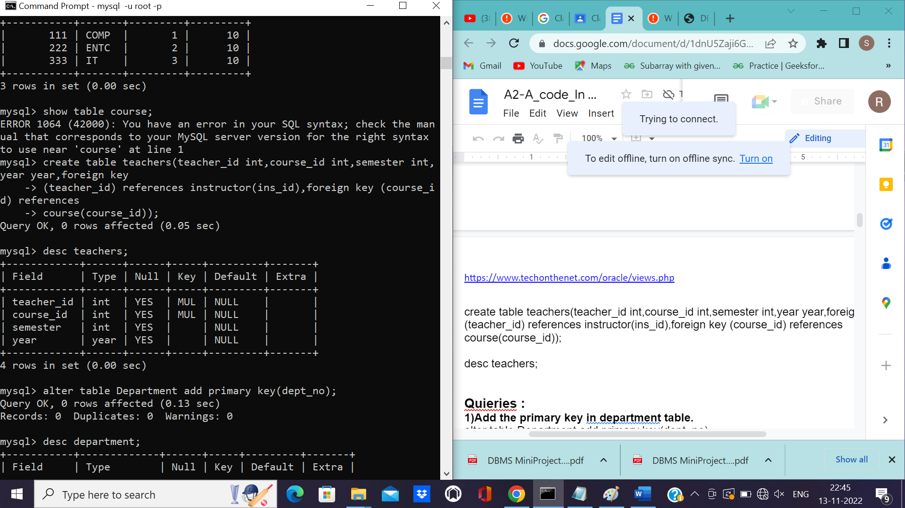

**Quieries :**

**1)Add the primary key in department table.**

mysql> alter table Department add primary key(dept_no);

Query OK, 0 rows affected (0.13 sec)

Records: 0 Duplicates: 0 Warnings: 0

mysql> desc department;

+-----------+-------------+------+-----+---------+-------+

| Field | Type | Null | Key | Default | Extra |

+-----------+-------------+------+-----+---------+-------+

| dept_no | int | NO | PRI | NULL | |

| dept_name | varchar(15) | YES | UNI | NULL | |

| bldg_name | varchar(15) | YES | | NULL | |

+-----------+-------------+------+-----+---------+-------+

3 rows in set (0.00 sec)

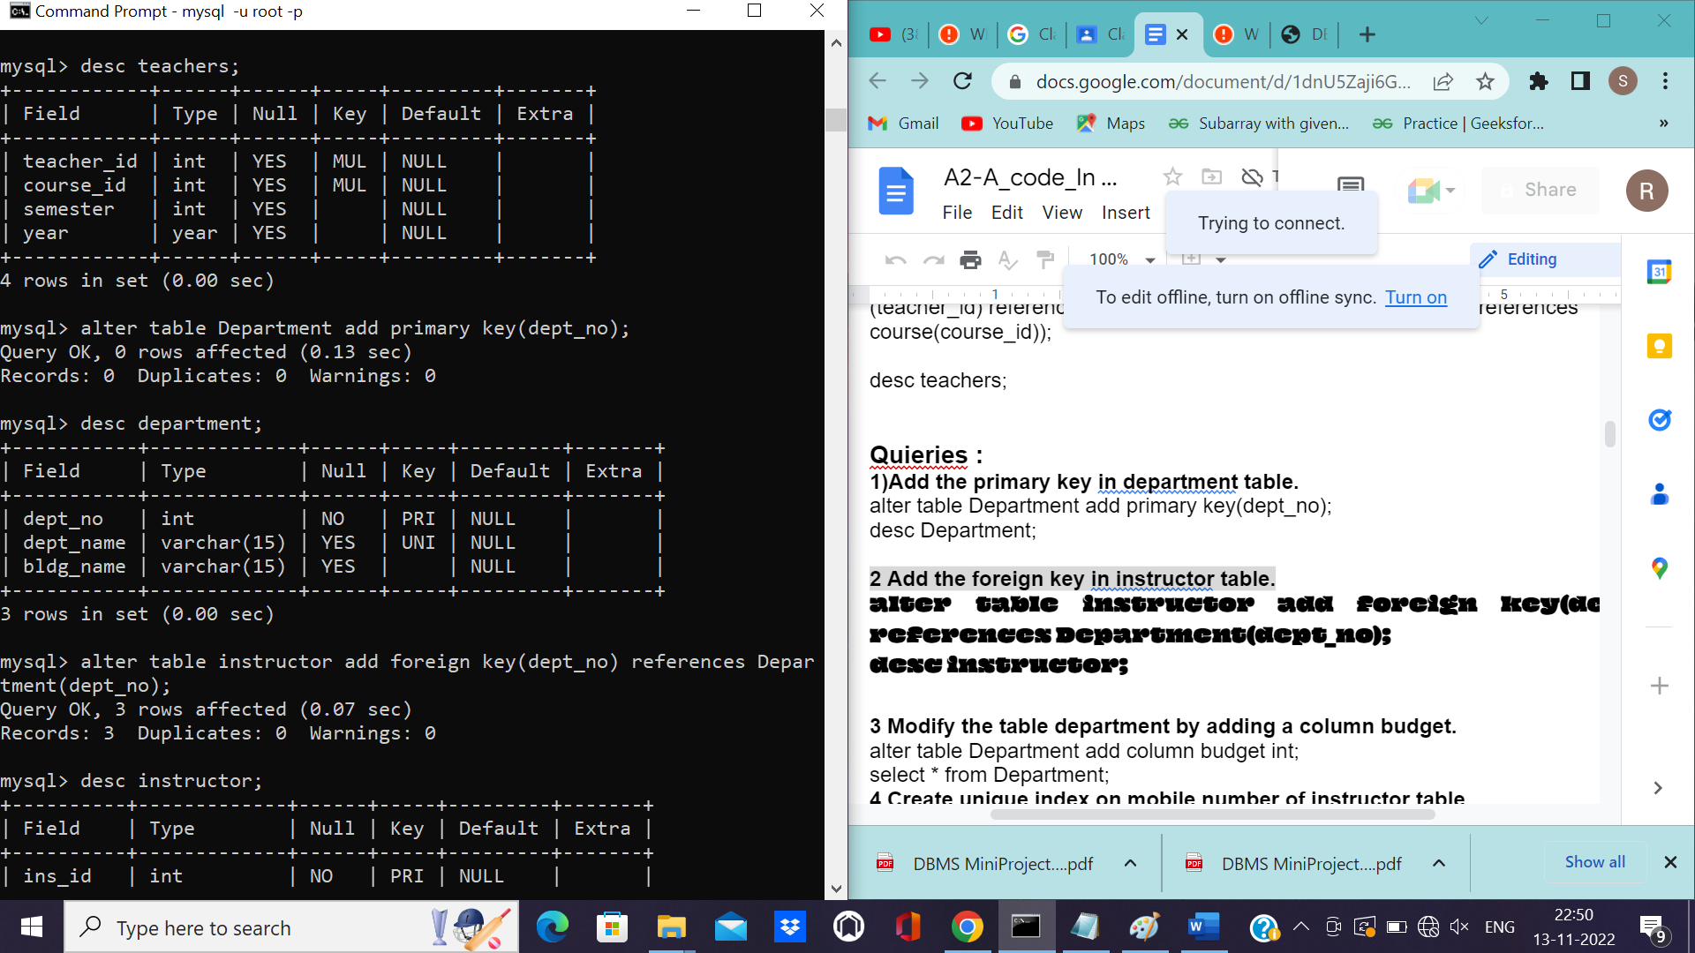

**2 Add the foreign key in instructor table.**

**mysql> alter table instructor add foreign key(dept_no) references Department(dept_no);**

**Query OK, 3 rows affected (0.07 sec)**

**Records: 3 Duplicates: 0 Warnings: 0**

**mysql> desc instructor;**

**+----------+-------------+------+-----+---------+-------+**

**| Field | Type | Null | Key | Default | Extra |**

**+----------+-------------+------+-----+---------+-------+**

**| ins_id | int | NO | PRI | NULL | |**

**| ins_name | varchar(15) | NO | | NULL | |**

**| dept_no | int | YES | MUL | NULL | |**

**| salary | int | YES | | NULL | |**

**| mob_no | int | YES | | NULL | |**

**+----------+-------------+------+-----+---------+-------+**

**5 rows in set (0.00 sec)**

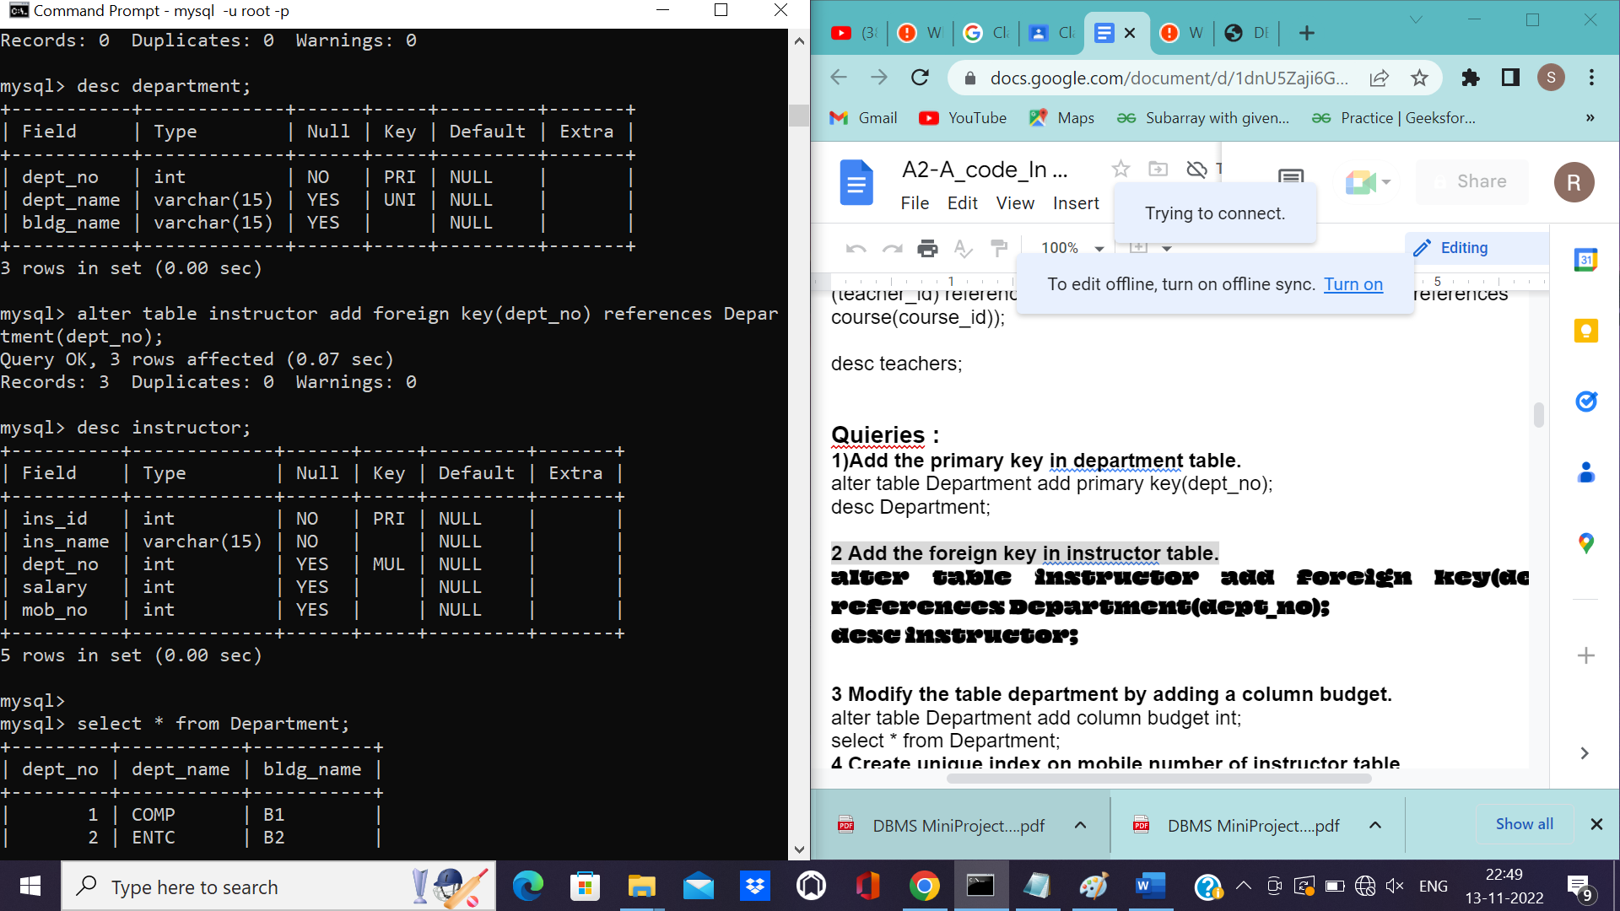

**Modify the table department by adding a column budget.**

mysql> select * from Department;

+---------+-----------+-----------+--------+

| dept_no | dept_name | bldg_name | budget |

+---------+-----------+-----------+--------+

| 1 | COMP | B1 | NULL |

| 2 | ENTC | B2 | NULL |

| 3 | IT | B3 | NULL |

+---------+-----------+-----------+--------+

3 rows in set (0.00 sec)

mysql> select * from Department;

+---------+-----------+-----------+--------+

| dept_no | dept_name | bldg_name | budget |

+---------+-----------+-----------+--------+

| 1 | COMP | B1 | NULL |

| 2 | ENTC | B2 | NULL |

| 3 | IT | B3 | NULL |

+---------+-----------+-----------+--------+

3 rows in set (0.00 sec)

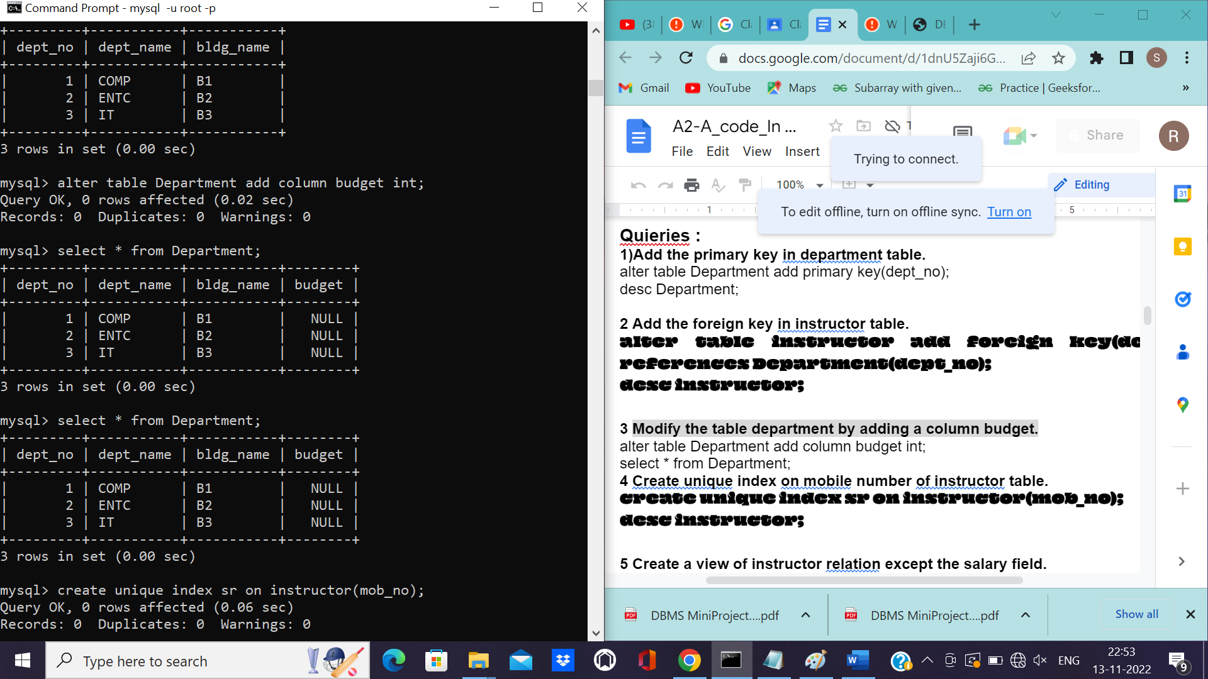

**Create unique index on mobile number of instructor table.**

mysql> create unique index sr on instructor(mob_no);

Query OK, 0 rows affected (0.06 sec)

Records: 0 Duplicates: 0 Warnings: 0

mysql> desc instructor;

+----------+-------------+------+-----+---------+-------+

| Field | Type | Null | Key | Default | Extra |

+----------+-------------+------+-----+---------+-------+

| ins_id | int | NO | PRI | NULL | |

| ins_name | varchar(15) | NO | | NULL | |

| dept_no | int | YES | MUL | NULL | |

| salary | int | YES | | NULL | |

| mob_no | int | YES | UNI | NULL | |

+----------+-------------+------+-----+---------+-------+

5 rows in set (0.00 sec)

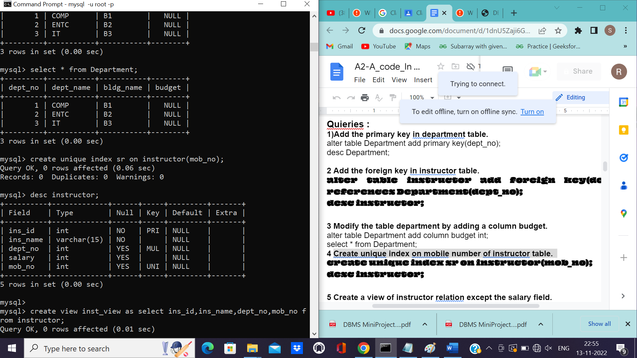

**Create a view of instructor relation except the salary field.**

mysql> create view inst_view as select ins_id,ins_name,dept_no,mob_no from instructor;

Query OK, 0 rows affected (0.01 sec)

mysql> select * from inst_view;

+--------+----------+---------+-----------+

| ins_id | ins_name | dept_no | mob_no |

+--------+----------+---------+-----------+

| 11 | Kiran | 1 | 98 |

| 12 | Rohan | 2 | 987654321 |

| 13 | Hrituja | 3 | 987654222 |

+--------+----------+---------+-----------+

3 rows in set (0.00 sec)

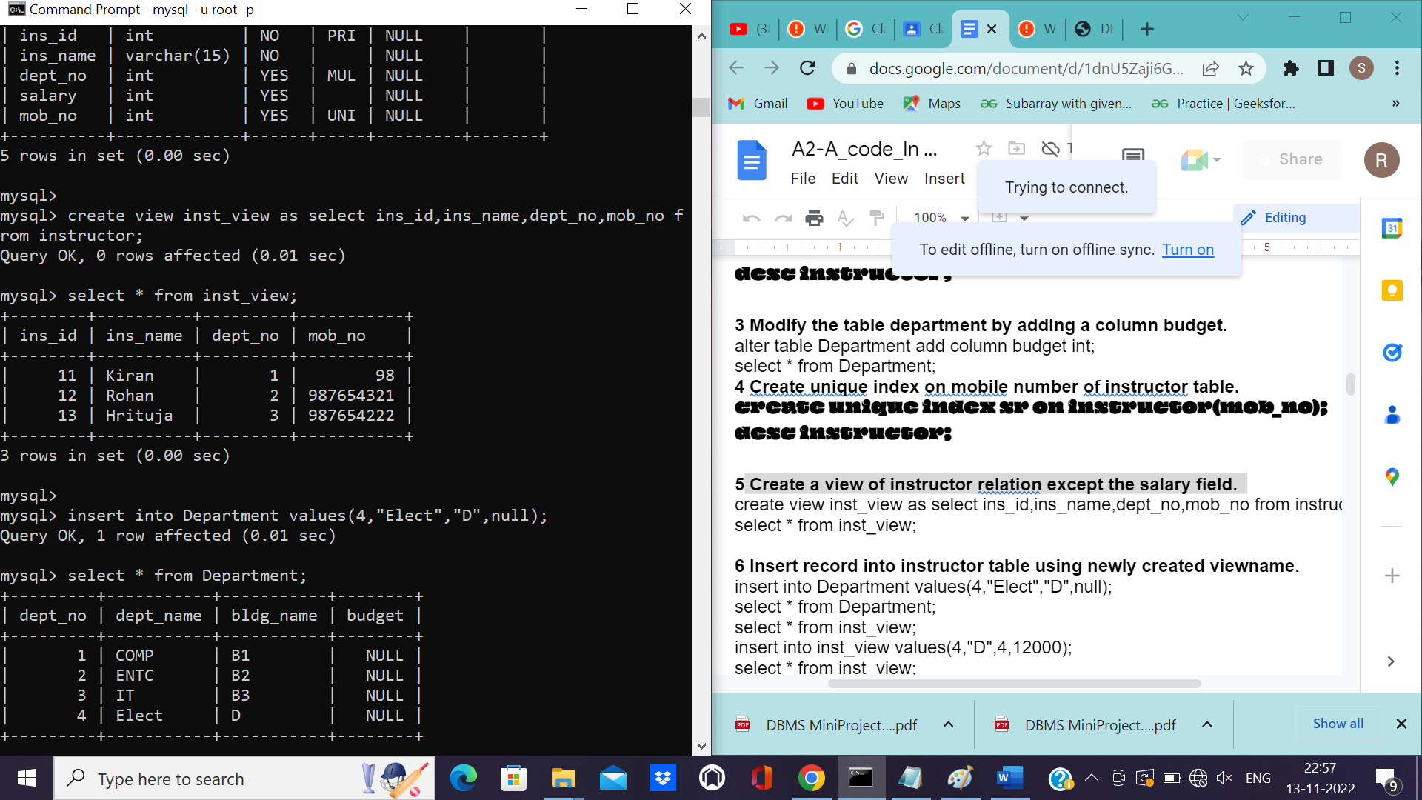

**Insert record into instructor table using newly created viewname.**

mysql> create view inst_view as select ins_id,ins_name,dept_no,mob_no from instructor;

Query OK, 0 rows affected (0.01 sec)

mysql> select * from inst_view;

+--------+----------+---------+-----------+

| ins_id | ins_name | dept_no | mob_no |

+--------+----------+---------+-----------+

| 11 | Kiran | 1 | 98 |

| 12 | Rohan | 2 | 987654321 |

| 13 | Hrituja | 3 | 987654222 |

+--------+----------+---------+-----------+

3 rows in set (0.00 sec)

mysql>

mysql> insert into Department values(4,"Elect","D",null);

Query OK, 1 row affected (0.01 sec)

mysql> select * from Department;

+---------+-----------+-----------+--------+

| dept_no | dept_name | bldg_name | budget |

+---------+-----------+-----------+--------+

| 1 | COMP | B1 | NULL |

| 2 | ENTC | B2 | NULL |

| 3 | IT | B3 | NULL |

| 4 | Elect | D | NULL |

+---------+-----------+-----------+--------+

4 rows in set (0.00 sec)

mysql> select * from inst_view;

+--------+----------+---------+-----------+

| ins_id | ins_name | dept_no | mob_no |

+--------+----------+---------+-----------+

| 11 | Kiran | 1 | 98 |

| 12 | Rohan | 2 | 987654321 |

| 13 | Hrituja | 3 | 987654222 |

+--------+----------+---------+-----------+

3 rows in set (0.00 sec)

mysql> insert into inst_view values(4,"D",4,12000);

Query OK, 1 row affected (0.01 sec)

mysql> select * from inst_view;

+--------+----------+---------+-----------+

| ins_id | ins_name | dept_no | mob_no |

+--------+----------+---------+-----------+

| 4 | D | 4 | 12000 |

| 11 | Kiran | 1 | 98 |

| 12 | Rohan | 2 | 987654321 |

| 13 | Hrituja | 3 | 987654222 |

+--------+----------+---------+-----------+

4 rows in set (0.00 sec)

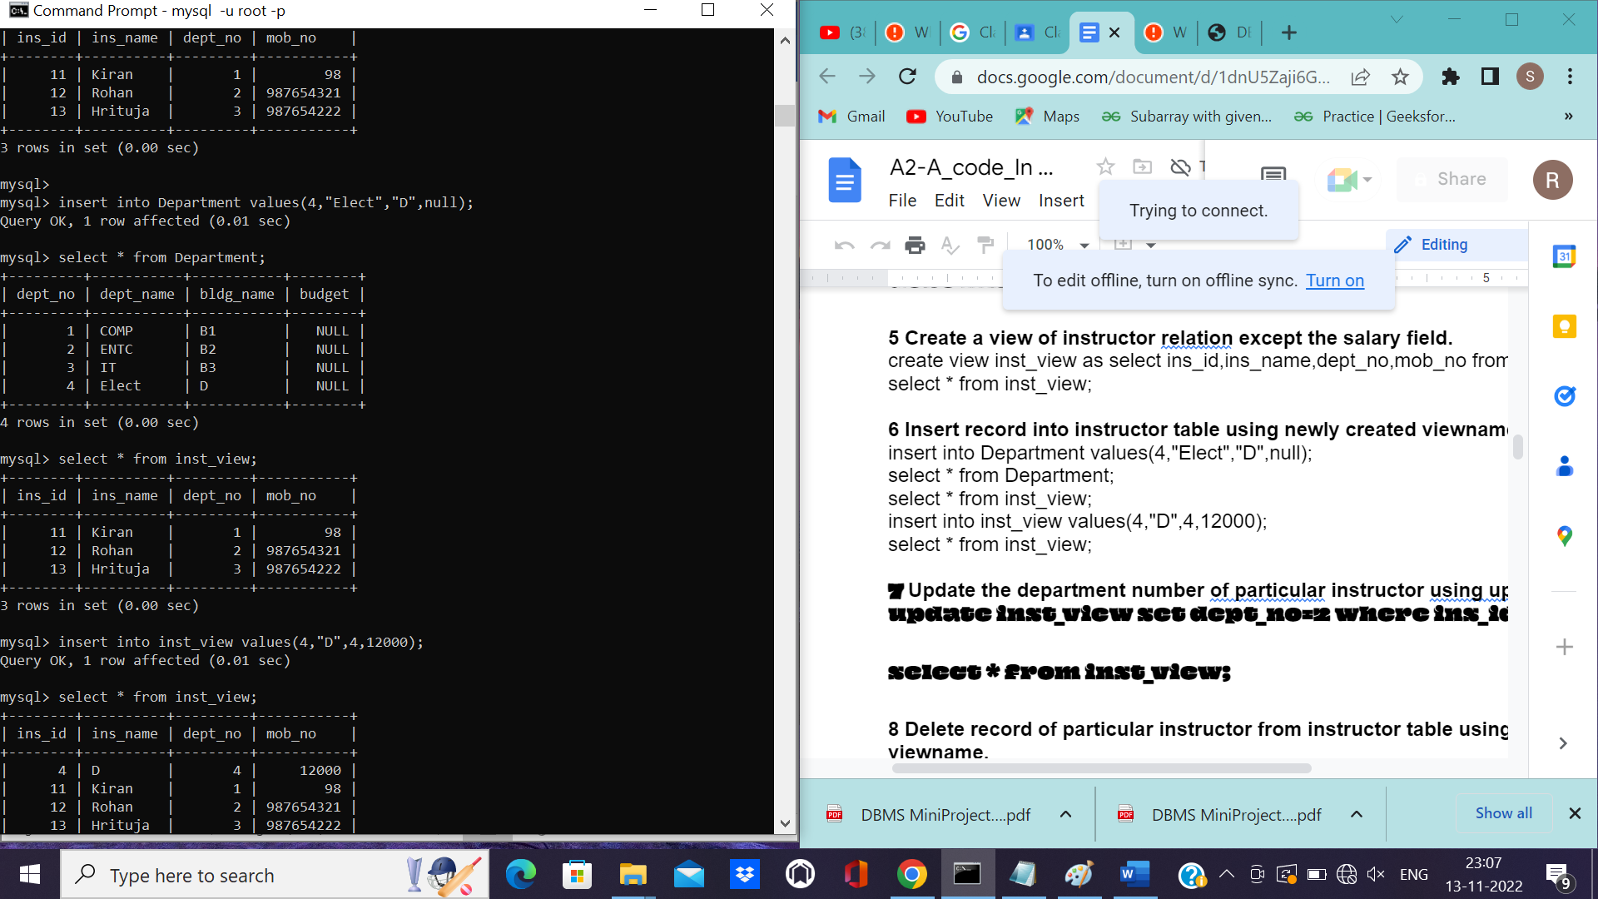

**Update the department number of particular instructor using update view mysql> update inst_view set dept_no=2 where ins_id=4;**

**Query OK, 1 row affected (0.01 sec)**

**Rows matched: 1 Changed: 1 Warnings: 0**

**mysql>**

**mysql> select * from inst_view;**

**+--------+----------+---------+-----------+**

**| ins_id | ins_name | dept_no | mob_no |**

**+--------+----------+---------+-----------+**

**| 4 | D | 2 | 12000 |**

**| 11 | Kiran | 1 | 98 |**

**| 12 | Rohan | 2 | 987654321 |**

**| 13 | Hrituja | 3 | 987654222 |**

**+--------+----------+---------+-----------+**

**4 rows in set (0.00 sec).**

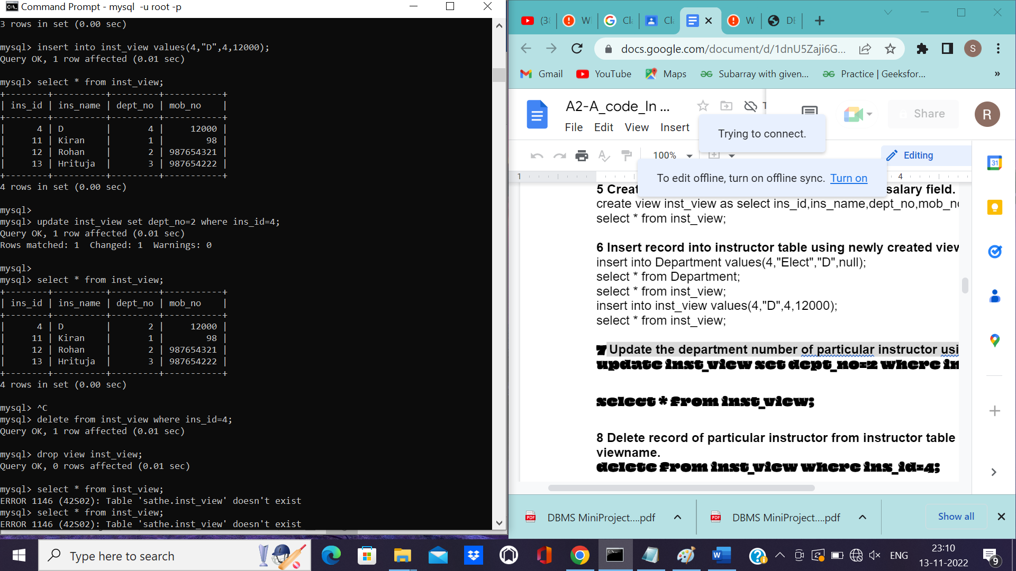

**Delete record of particular instructor from instructor table using newly created**

**viewname.**

mysql> delete from inst_view where ins_id=4;

Query OK, 1 row affected (0.01 sec)

**Delete the last view.**

mysql> drop view inst_view;

Query OK, 0 rows affected (0.01 sec)

**Increase the size of the title field of course relation.**

mysql> alter table course modify title varchar(20);

Query OK, 0 rows affected (0.02 sec)

Records: 0 Duplicates: 0 Warnings: 0

mysql> desc course;

+-----------+-------------+------+-----+---------+-------+

| Field | Type | Null | Key | Default | Extra |

+-----------+-------------+------+-----+---------+-------+

| course_id | int | NO | PRI | NULL | |

| title | varchar(20) | YES | | NULL | |

| dept_no | int | YES | | NULL | |

| credits | int | YES | | NULL | |

+-----------+-------------+------+-----+---------+-------+

4 rows in set (0.00 sec)

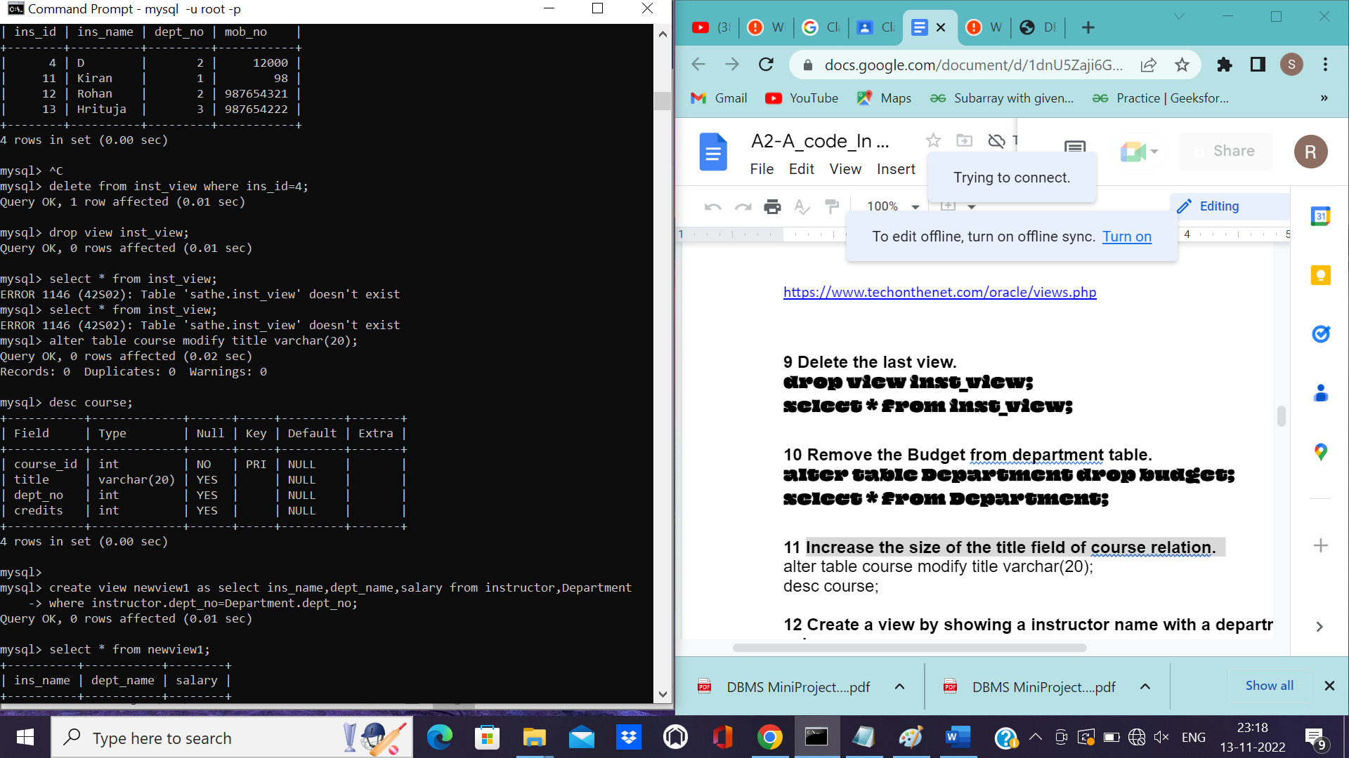

**Create a view by showing a instructor name with a department name and its**

**salary.**

> create view newview1 as select ins_name,dept_name,salary from instructor,Department

-> where instructor.dept_no=Department.dept_no;

Query OK, 0 rows affected (0.01 sec)

mysql> select * from newview1;

+----------+-----------+--------+

| ins_name | dept_name | salary |

+----------+-----------+--------+

| Kiran | COMP | 20000 |

| Rohan | ENTC | 20000 |

| Hrituja | IT | 20000 |

+----------+-----------+--------+

3 rows in set (0.00 sec)

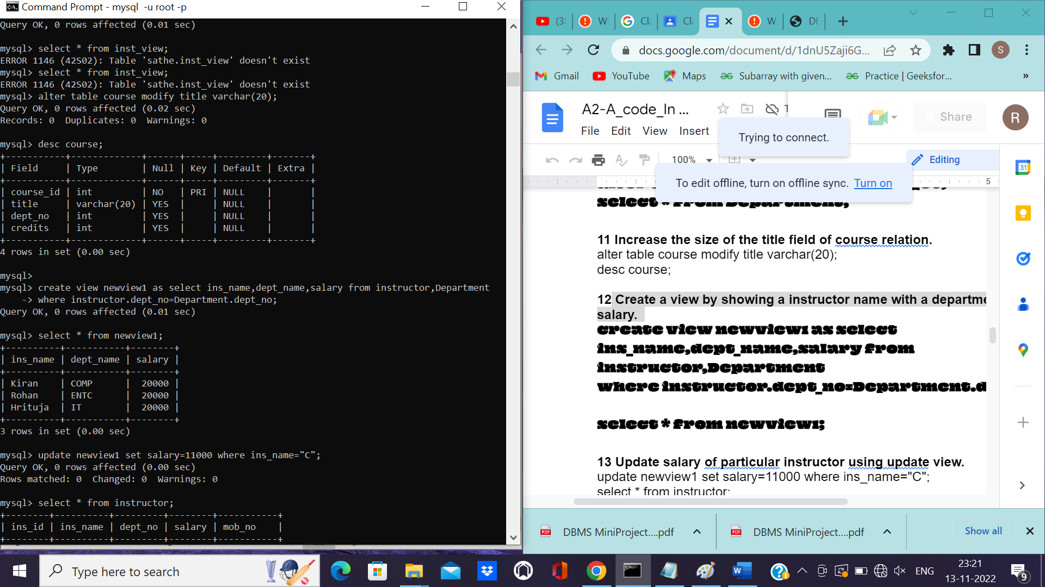

**Update salary of particular instructor using update view.**

mysql> update newview1 set salary=11000 where ins_name="C";

Query OK, 0 rows affected (0.00 sec)

Rows matched: 0 Changed: 0 Warnings: 0

mysql> select * from instructor;

+--------+----------+---------+--------+-----------+

| ins_id | ins_name | dept_no | salary | mob_no |

+--------+----------+---------+--------+-----------+

| 11 | Kiran | 1 | 20000 | 98 |

| 12 | Rohan | 2 | 20000 | 987654321 |

| 13 | Hrituja | 3 | 20000 | 987654222 |

+--------+----------+---------+--------+-----------+

3 rows in set (0.00 sec)

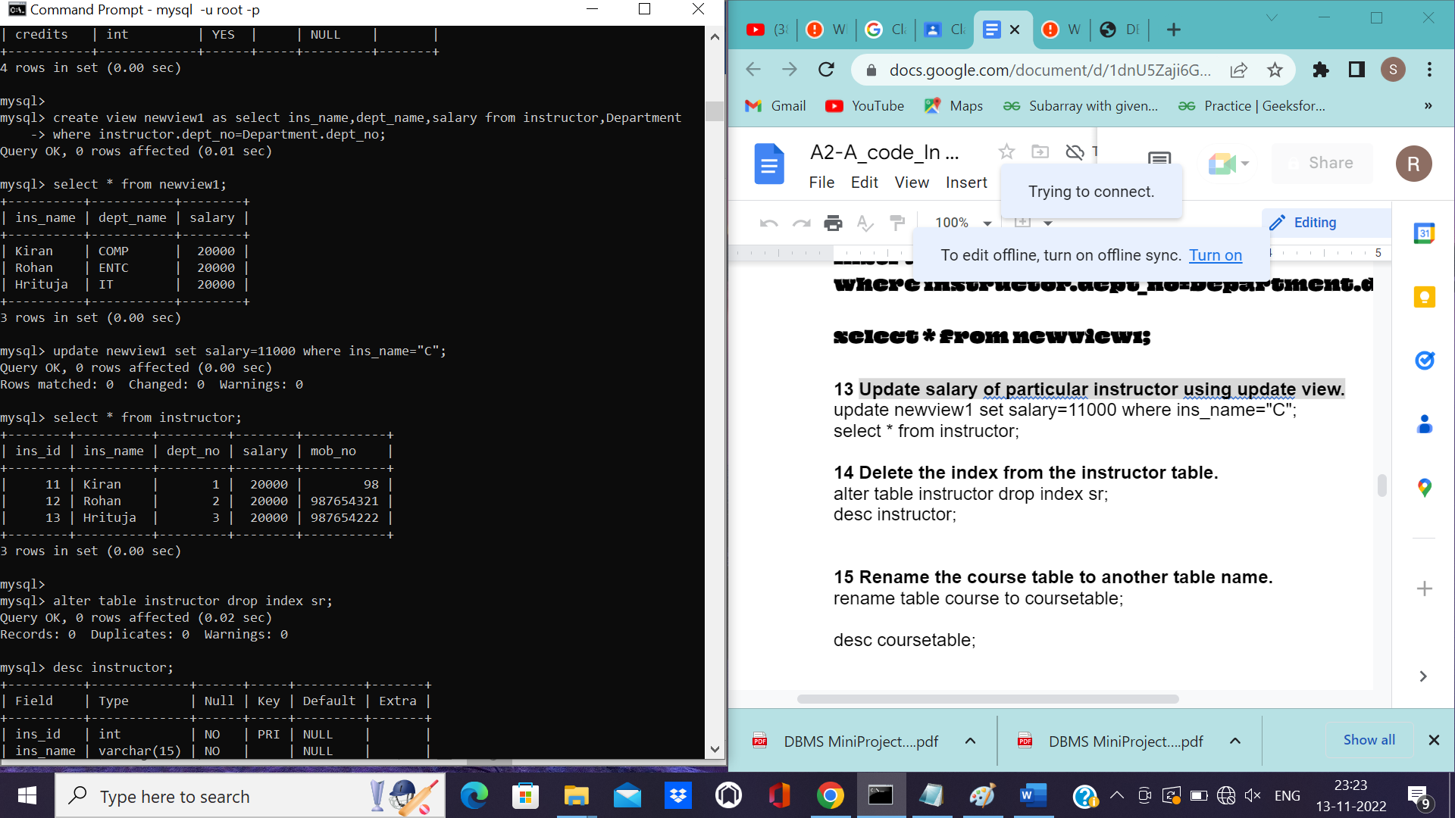

**Delete the index from the instructor table**

mysql> alter table instructor drop index sr;

Query OK, 0 rows affected (0.02 sec)

Records: 0 Duplicates: 0 Warnings: 0

mysql> desc instructor;

+----------+-------------+------+-----+---------+-------+

| Field | Type | Null | Key | Default | Extra |

+----------+-------------+------+-----+---------+-------+

| ins_id | int | NO | PRI | NULL | |

| ins_name | varchar(15) | NO | | NULL | |

| dept_no | int | YES | MUL | NULL | |

| salary | int | YES | | NULL | |

| mob_no | int | YES | | NULL | |

+----------+-------------+------+-----+---------+-------+

5 rows in set (0.00 sec)

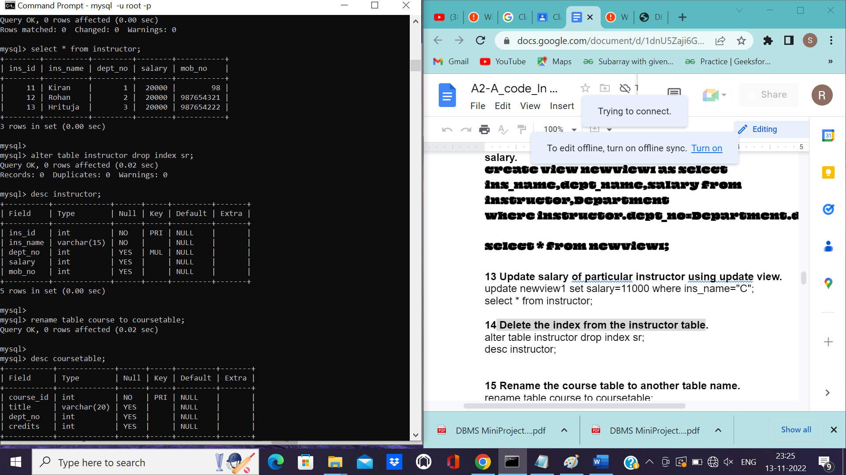

**Rename the course table to another table name.**

mysql> rename table course to coursetable;

Query OK, 0 rows affected (0.02 sec)

mysql>

mysql> desc coursetable;

+-----------+-------------+------+-----+---------+-------+

| Field | Type | Null | Key | Default | Extra |

+-----------+-------------+------+-----+---------+-------+

| course_id | int | NO | PRI | NULL | |

| title | varchar(20) | YES | | NULL | |

| dept_no | int | YES | | NULL | |

| credits | int | YES | | NULL | |

+-----------+-------------+------+-----+---------+-------+

4 rows in set (0.00 sec)

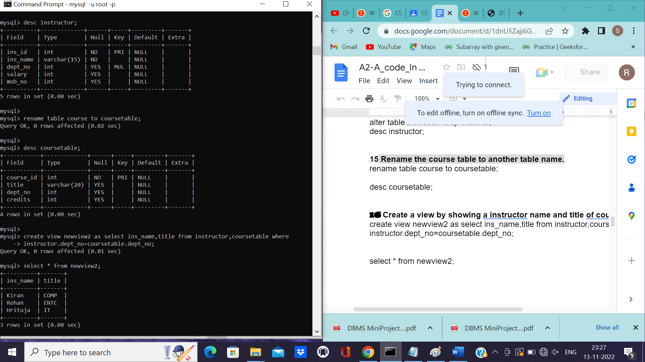

**Create a view by showing a instructor name and title of course he teaches.**

mysql> create view newview2 as select ins_name,title from instructor,coursetable where

-> instructor.dept_no=coursetable.dept_no;

Query OK, 0 rows affected (0.01 sec)

mysql> select * from newview2;

+----------+-------+

| ins_name | title |

+----------+-------+

| Kiran | COMP |

| Rohan | ENTC |

| Hrituja | IT |

+----------+-------+

3 rows in set (0.00 sec)

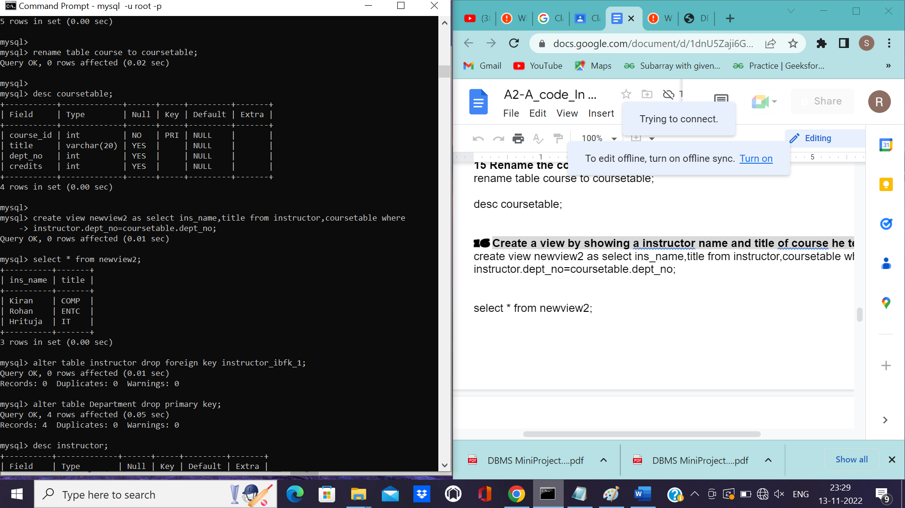

**Delete the key from the department table.**

mysql> alter table instructor drop foreign key instructor_ibfk_1;

Query OK, 0 rows affected (0.01 sec)

Records: 0 Duplicates: 0 Warnings: 0

mysql> alter table Department drop primary key;

Query OK, 4 rows affected (0.05 sec)

Records: 4 Duplicates: 0 Warnings: 0

mysql> desc instructor;

+----------+-------------+------+-----+---------+-------+

| Field | Type | Null | Key | Default | Extra |

+----------+-------------+------+-----+---------+-------+

| ins_id | int | NO | PRI | NULL | |

| ins_name | varchar(15) | NO | | NULL | |

| dept_no | int | YES | MUL | NULL | |

| salary | int | YES | | NULL | |

| mob_no | int | YES | | NULL | |

+----------+-------------+------+-----+---------+-------+

5 rows in set (0.00 sec)

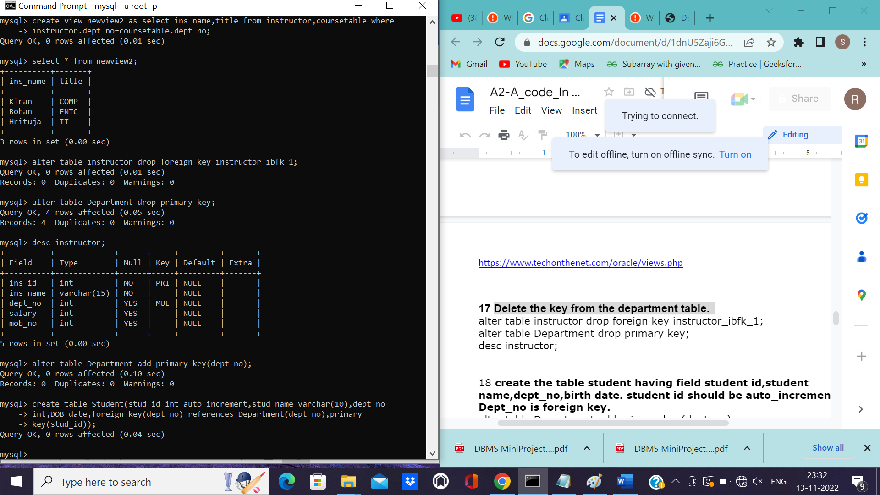

**create the table student having field student id,student**

**name,dept_no,birth date. student id should be auto_increment.**

**Dept_no is foreign key.**

mysql> alter table Department add primary key(dept_no);

Query OK, 0 rows affected (0.10 sec)

Records: 0 Duplicates: 0 Warnings: 0

mysql> create table Student(stud_id int auto_increment,stud_name varchar(10),dept_no

-> int,DOB date,foreign key(dept_no) references Department(dept_no),primary

-> key(stud_id));

Query OK, 0 rows affected (0.04 sec)

mysql>

mysql> desc Student;

+-----------+-------------+------+-----+---------+----------------+

| Field | Type | Null | Key | Default | Extra |

+-----------+-------------+------+-----+---------+----------------+

| stud_id | int | NO | PRI | NULL | auto_increment |

| stud_name | varchar(10) | YES | | NULL | |

| dept_no | int | YES | MUL | NULL | |

| DOB | date | YES | | NULL | |

+-----------+-------------+------+-----+---------+----------------+

4 rows in set (0.00 sec)

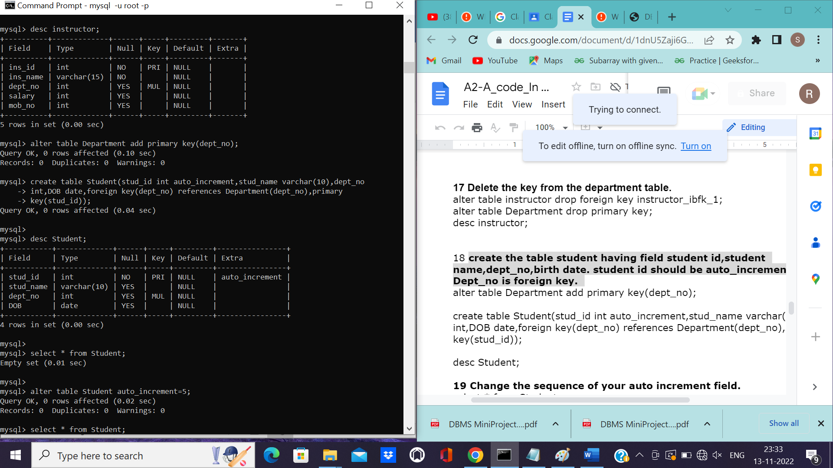

**Change the sequence of your auto increment field.**

mysql> select * from Student;

Empty set (0.01 sec)

mysql>

mysql> alter table Student auto_increment=5;

Query OK, 0 rows affected (0.02 sec)

Records: 0 Duplicates: 0 Warnings: 0

mysql> select * from Student;

Empty set (0.00 sec)

**Create the view of computer department teachers name who teaches**

**in 5th semester.**

mysql> create view new1 as select dept_name,semester,ins_name from

-> Department,teachers,instructor where teachers.semester=2 and

-> Department.dept_name="comp" and instructor.ins_id=teachers.teacher_id and

-> instructor.dept_no=Department.dept_no;

Query OK, 0 rows affected (0.01 sec)

mysql> select * from new1;

Empty set (0.00 sec)

